Detailed Report Regarding Decrease In Average Trip Duration

## Key Observations:

1. Total no of trip counts has been decreased from 1315404 to 1307543
2. Change in user type:

Increase in Subscriber and decrease in customer

|  |  |  |  |
| --- | --- | --- | --- |
| **User type** | **Apr-17** | **Apr-18** | **Change (%)** |
| Subscriber | 1125079 | 1157158 | 2.85 |
| Customer | 184884 | 146194 | -20.93 |

|  |  |  |  |
| --- | --- | --- | --- |
| **Gender** | **Apr-17** | **Apr-18** | **Change (%)** |
| Female | 286958 | 293086 | 2.14 |
| Male | 853571 | 889041 | 4.16 |
| Unknown | 169434 | 121225 | -28.45 |

1. A significant decrease can be shown in the users with ‘unknown’ gender type
2. 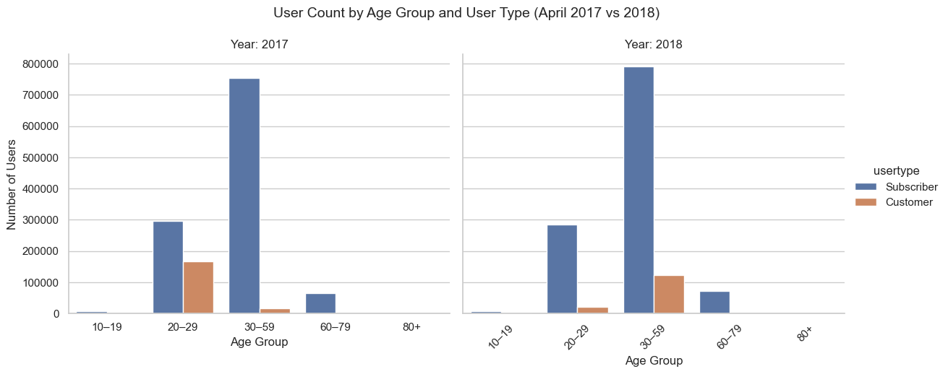No of users in 20-29 age group have been decreased and that decreases is majorly in ‘Customer’ user type.

|  |  |  |
| --- | --- | --- |
| **Stations** | **Apr-17** | **Apr18** |
| Start | 613 | 764 |
| End | 622 | 770 |

1. Expansion in no of stations:

|  |  |  |
| --- | --- | --- |
| **Stations** | **Gini Apr-17** | **Gini Apr-18** |
| Start | 0.453 | 0.484 |
| End |  |  |

A significant amount of increase can be seen in starting and ending stations

From Gini coefficient we can observe that each stations have been equally used in both years.

1. Density if ending stations has been increased:

2017 Ending Station density: 3.51 stations/km²

2018 Ending Station density: 3.59 stations/km²

Density increased by 2.32%

1. 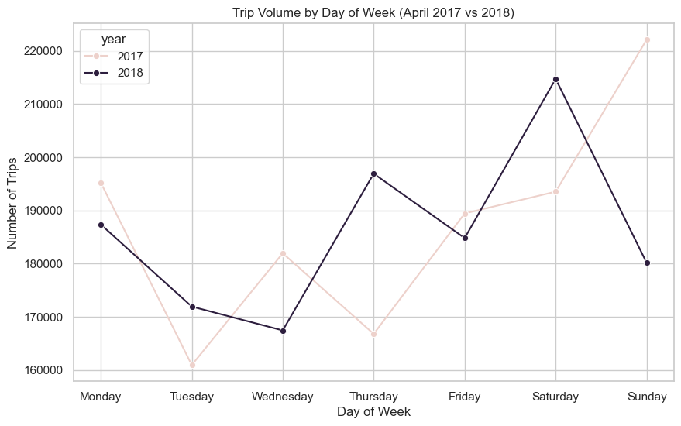Increase in no of trips in weak days in significant decrease in week end

### Conclusion:

* Decrease in ‘Customer’ user count caused significant decrease in average trip duration as ‘Customer’ are casual rider they usually take longer trips.
* Drop in young riders mostly in 20-29 age group creates a drop in average trip duration.
* We can notice an significant decrease in ‘Unknown’ gender type who used to take longer trips between 20-29 age group resulting a drop in average trip duration.
* Expansion in no of stations can lead to a shorter trip.
* Increase in no of trips in week days ad decrease in no of trips in week end results in shorter trip drip duration as week days are known for scheduled trip and week end in preferred for casual riding.

### c) Recommendations for further investigation or action:

* Further investigation is recommended with few more constrains like Weather Condition and Road Condition.
* Marketing Campaign, Attractive offers, and tour package can be introduced to attract young casual riders.